Homework 0: Prerequisites Check-in / Warm-up
CSCI 3302: Introduction to Robotics
Report due 1/16/25 @ 11:59pm
Total points: 25
Pro tip: Use Piazza or Office Hours if you are stuck

Submission Instructions:
- Write your code for Q3-4 in the provided Python files (please do not change the python file names and the function signature).
- Create a PDF with detailed, step-by-step solutions to problems 1-2.
- Zip your 3 files (Q3.py, Q4.py, and HW0.pdf) and submit on Canvas. Your zip folder should be titled HW0_lastname.zip. If you don’t follow these naming conventions for the zip folder and .py + .pdf files, the grading script will most likely erroneously give you a zero, so please adhere to these requirements.
- You should complete these tasks on your own and without external help. We will check for plagiarism.
- Please attend office hours if you need support. We are here to help!

Algebra

We need to see your steps and/or justifications for this section. Simply providing an answer won’t earn you full credit.

- [3 pts] Given vector v = < 3, -1, 3 >, find a vector w that is orthogonal to v. Please give a nontrivial solution which is not <0, 0, 0>.

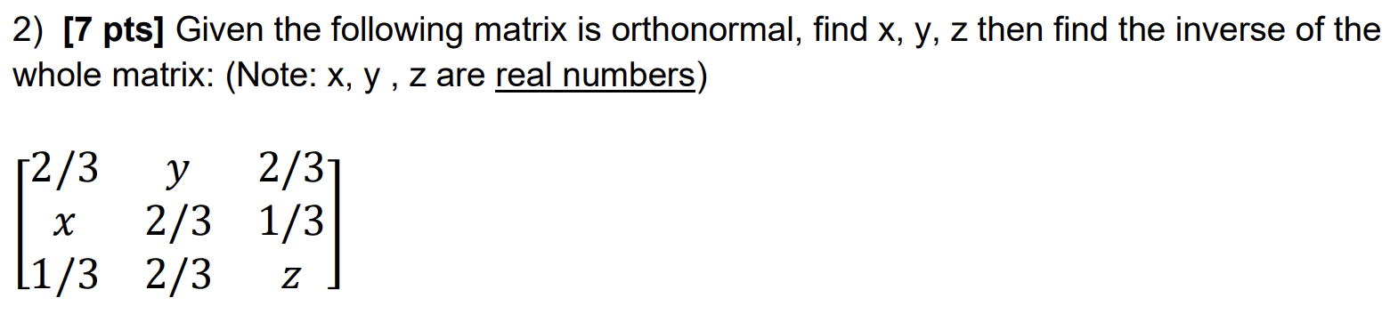

Shortest Path in a grid (coding)

- [5 pts] (Coding) NASA’s Perseverance is on Mars and has mapped out an obstacle free square sector with grids. The free space is represented with 0s. Help It save precious energy by figuring out the shortest path from a given start position on this grid to a goal position. It cannot travel diagonally due to some issues. Assume that the grid is square and the number of cells on the path is the length of the path including the start and the goal cells. Complete the provided python function. Do not forget to add comments to your code. Here is an example -

grid = [[0,0,0,0],
[0,0,0,0],
[0,0,0,0],
[0,0,0,0]]
start, goal = (0,0), (3,2)
Solution = 6

grid = [[0,0,0,0],
[0,0,0,0],
[0,0,0,0],
[0,0,0,0]]
start, goal = (0,0), (3,2)
Solution = 6

Note: Do not return the shortest path but just a single integer representing the length of the shortest path.
Note: Please verify the solution in more test cases.

- [10 pts] (Coding) Perseverance is able to perform some science thanks to you. It now spots a sector that has obstacles represented by 1s. Keeping the assumptions same as Q3, return the length of the shortest path avoiding obstacles. Return -1 if no such path exists.
Hints:
- Don’t explore neighboring cells that don’t exist (are beyond the grid’s boundary)
- Don’t explore neighboring cells that are obstacles.
- Don’t revisit a cell.
- Your search ends when there is nothing to explore.
- You will have to propagate the information of the explored length so far.
- CSCI 2270

Here are some examples.
a)
grid = [[0,0,0,1],
[1,0,0,0],
[1,0,1,0],
[1,1,0,0]]
start, goal = (3,2), (0,0)
Solution = 8
b)
grid = [[0,1],
[1,0]]
start, goal = (0, 0), (1,1)
Solution = -1 ---> Perseverance can’t travel diagonally and thus, there doesn’t exist any feasible path.

Note: Please verify the solution in more test cases.

